# Star Wars Lore Site Plan

## Ty Budvarson

## WDD 130

## Overview

### Purpose

To educate on the changes to Star Wars lore,

that was changed through Disney’s acquisition of Lucas films.

### Audience

Star Wars Enthusiasts.

## Branding

### Website Logo

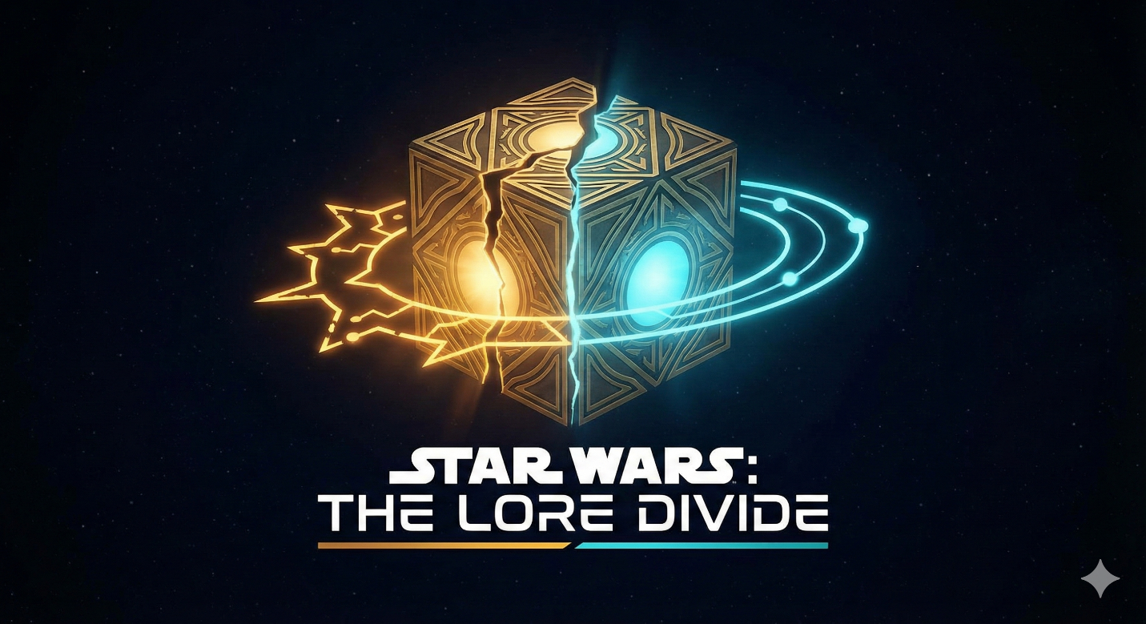

## Style Guide

### Color Palette

|  |  |  |
| --- | --- | --- |
| **Deep Space (Background):** | **Holocron White (Primary Text):** | **Archive Gray (Secondary Backgrounds/Cards):** |
| #121216 | #EAEAEA | #1E1E24 |
| Legends Amber (Accent A - Pre-Disney): | Canon Cyan (Accent B - Post-Disney): |  |
| #D4AF37 | #00BFFF |  |

### Typography

#### Heading Font: "Chakra Petch"

#### Paragraph Font: "Inter"

### Navigation

The Acquisition The Clone Wars Post-Battle of Endor

**Content**

[put all content for the pages here, including written text and images]

**The Acquisition**

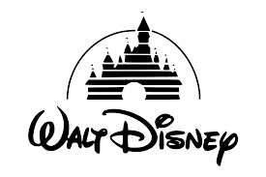

Disney acquired Lucasfilm for $4.05 billion on October 30, 2012, a deal that included the Star Wars franchise, LucasArts, Industrial Light & Magic, and Skywalker Sound. Founder George Lucas sold the company so he could pass Star Wars to a new generation.

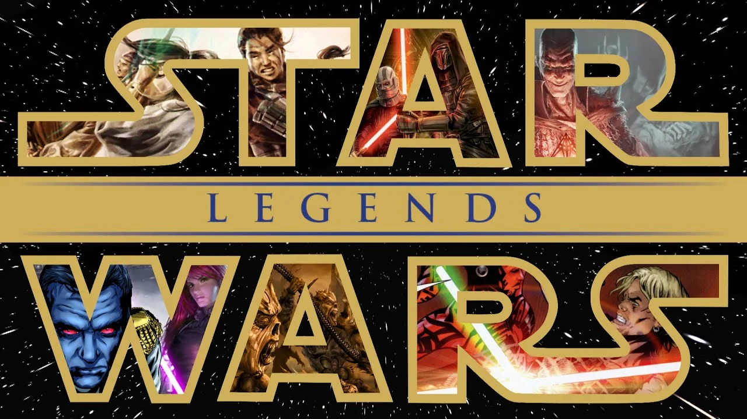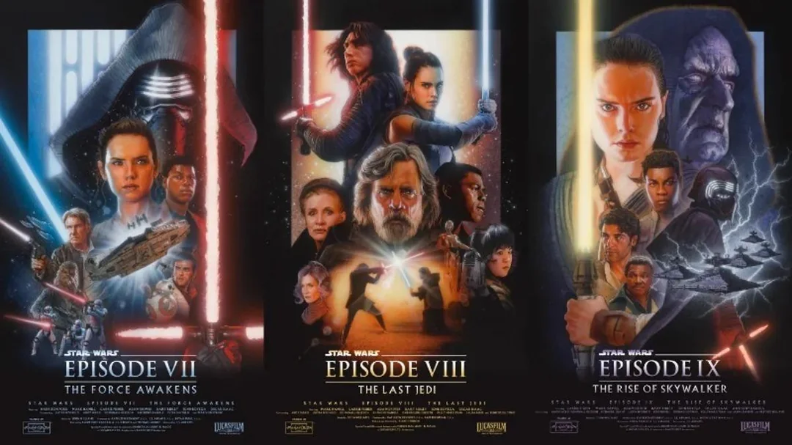

After Disney bought Lucasfilm, the most significant change was declaring the vast majority of previously existing lore, now called the Expanded Universe (EU), as non-canon. This meant that stories from books, comics, and games, including characters like Darth Bane and concepts like the Reconquest of Ryloth, were wiped out to make way for new stories and a fresh continuity for the sequel films.

**The Clone Wars**

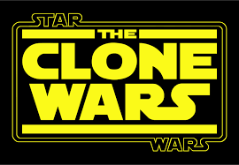

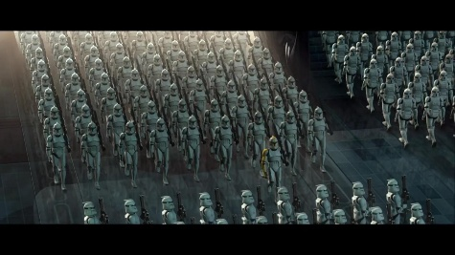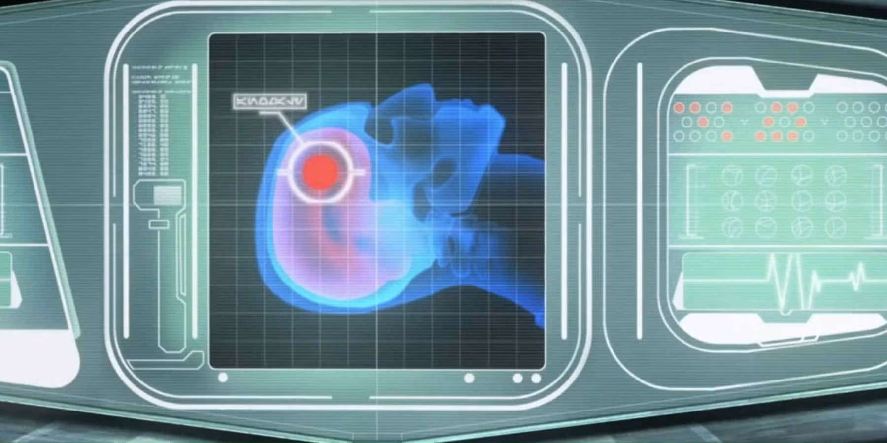

The clones in the old lore were the perfect soldiers. They never questioned orders, believed in the republic and were willing to kill all jedi at the drop of a had based squarely on their training and discipline. After the Disney acquisition the clones then became real people all with different hopes and dreams. With that growth of individualistic traits the lore changed that the only way to make the clones turn on their own generals without questioning orders was to have an inhibitor chip inside every single one. Only being brainwashed were the clones able to fulfill their duty to genocide the jedi.

**Post-Battle of Endor**

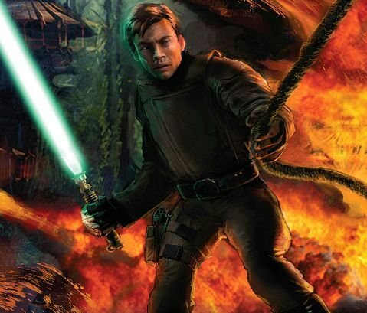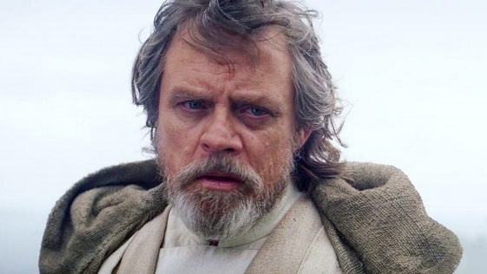

Luke Skywalker is an entirely different man in legends and ep 7. In legends he is this great warrior willing to do anything to help the galaxy. While in ep 7 he is an old man with no more hopes and dreams just living the rest of his life secluded on an island waiting to die.

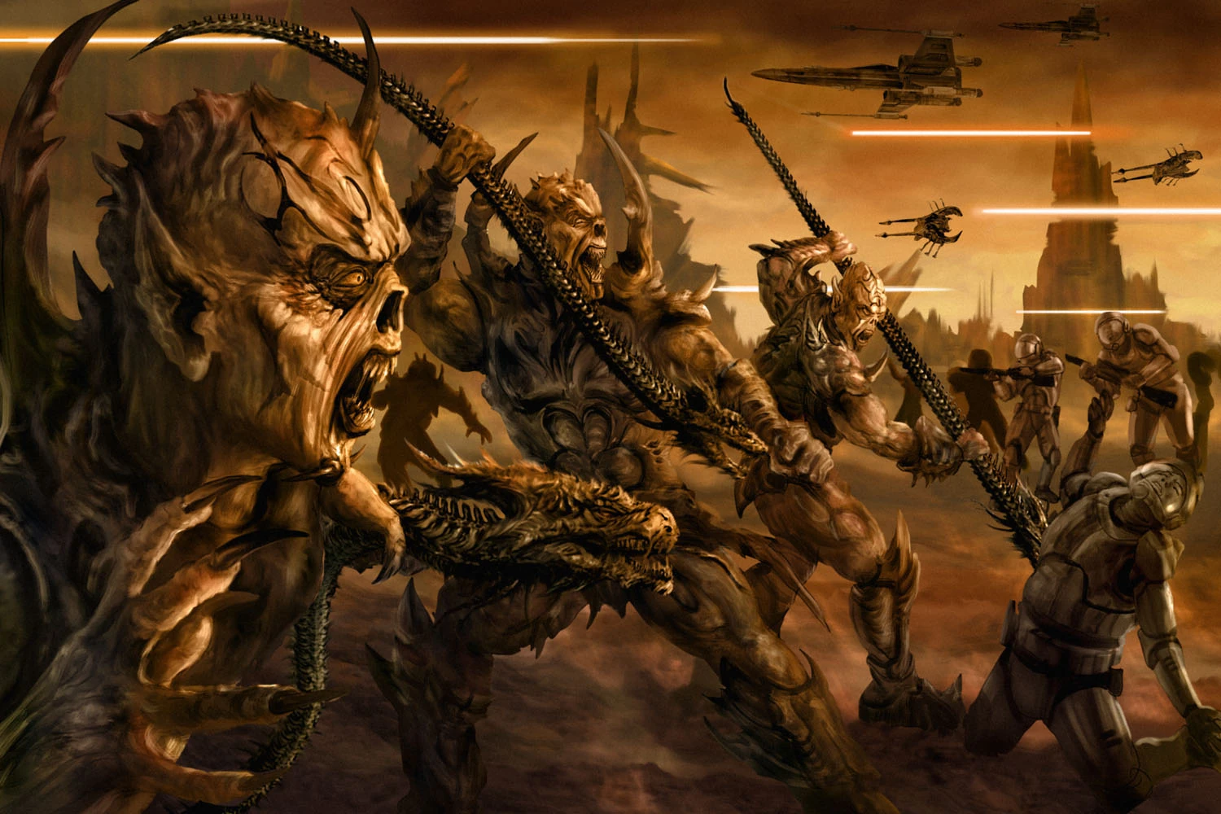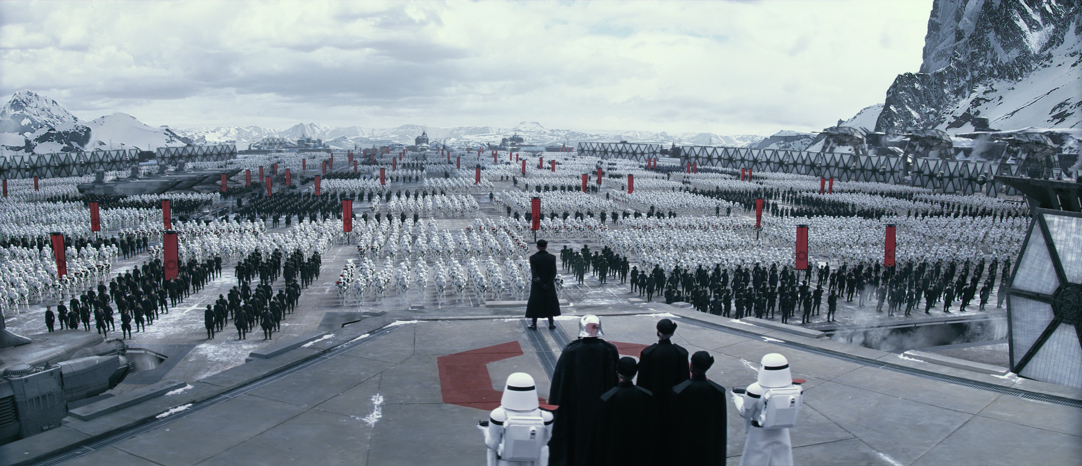

The galaxy itself is really different, in Legends they comes a Galactic invasion force called the Yuuzhan Vong. These Devel like aliens all worship a god who revels in the pain inflicted and the pain others inflict on his followers. They have a Hate for all machines and only use bio equipment and ships. While in the Disney cannon the galaxy has risen another ‘Empire’ called the First Order, they built another ‘Death Star’ called Starkiller Base. Which is bigger and badder than the last one.

**Wireframes**

### The Acquisition

### The Clone Wars

### Post-Battle of Endor

